**Installation instructions for Android Studio in Windows**

**Pre-requisites :**

1. Install JDK in your machine. (java version "1.8.0_11")

**Follow the below steps :**

1. Download **Android Studio** from <http://developer.android.com/sdk/installing/studio.html> and run the application - “android-studio-bundle-135.1245622-windows.exe”

(As the studio plugins consumes more memory, it is safe to install the software in the drive having more memory space)

1. After installation set the path for Android Studio
   1. create an environment variable ‘**JAVA_HOME** ‘ with value ‘**C:\Program Files\Java\jdk1.8.0_11**’
   2. ensure that the **path** variable also has the value ‘**C:\Program Files\Java\jdk1.8.0_11\bin**’

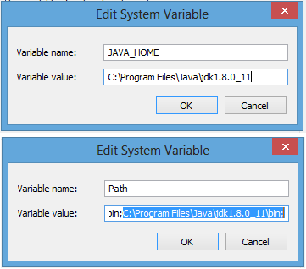

* 1. create an environment variable ‘**ANDROID_HOME**’with value

‘/path/to/Android/android-studio/sdk’ and ensure that the **ANDROID_HOME** is added to **path** variable

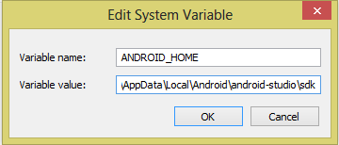

2.4 also add ‘path/to/ Android/android-studio/sdk/platform-tools’ to **path** variable.

1. Now launch the Android Studio application

